**HOW TO INSTALL.**

**how to install Database.**

1. Open Sqlserver 2008
2. restore database

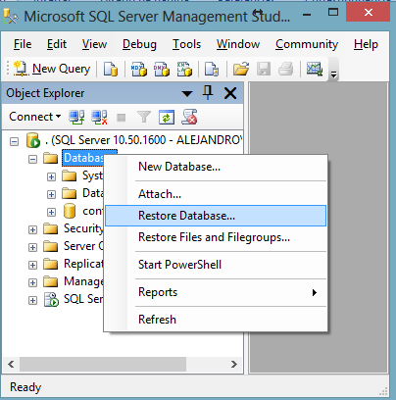

Follow the instructions with the numbers

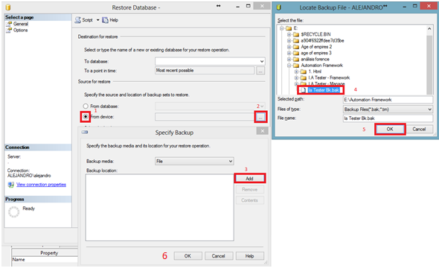

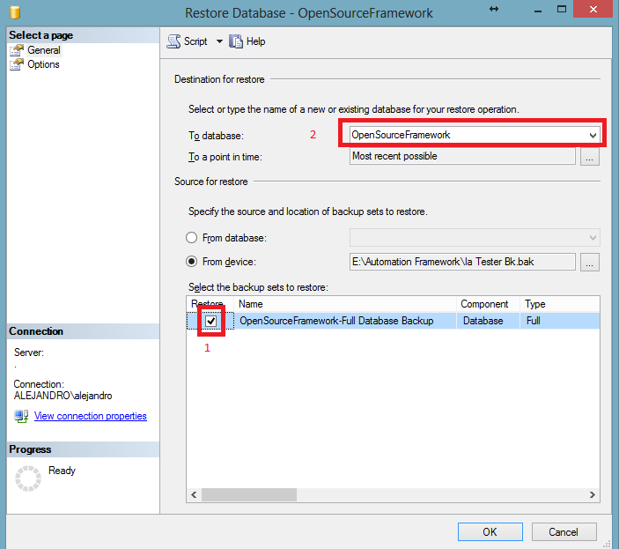

**how to install Framework.**

1. Copy "I.A Tester - Workspace" and "1. Html" in a folder.
2. open eclipse and select the workspace "I.A Tester - Workspace"
3. when eclipse is opened organize the imports.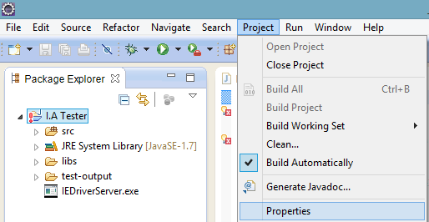
4. Then go to Java Build Path/Libraries and remove all except "JRE SYSTEM LIBRARY"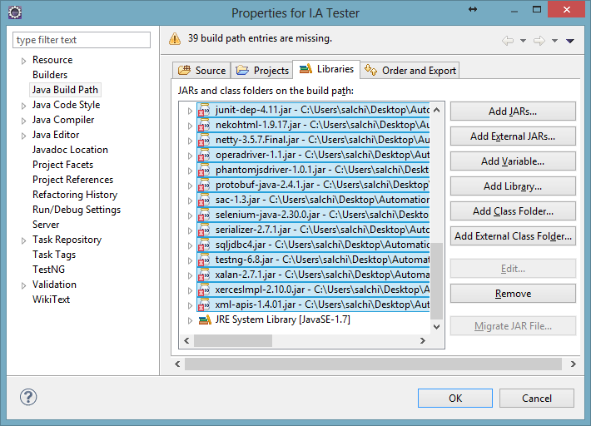

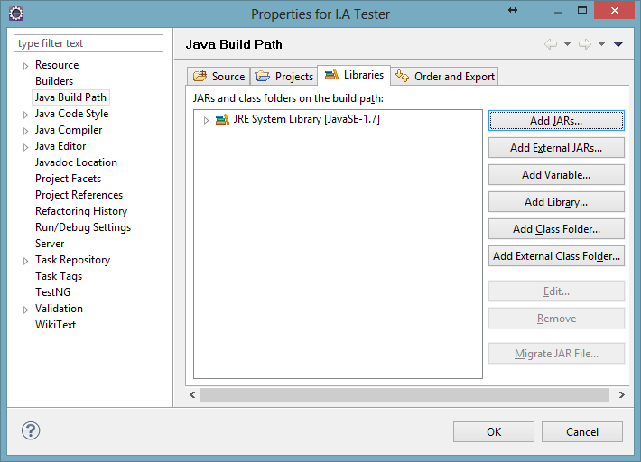

1. click button "Add External JARs"
2. go to "I.A Tester - Workspace\I.A Tester\libs" and add all the files in folder

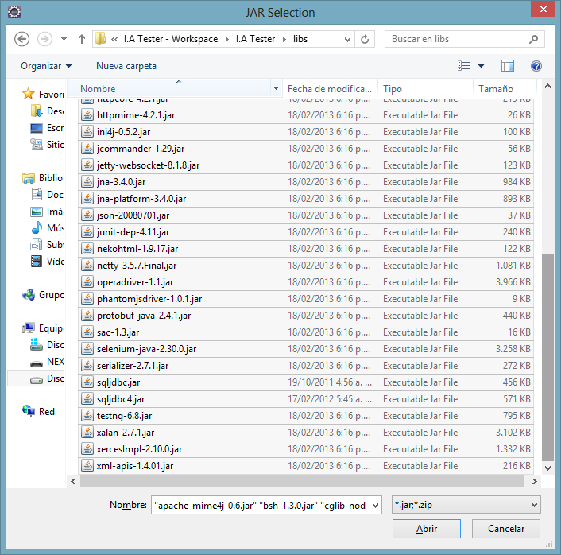

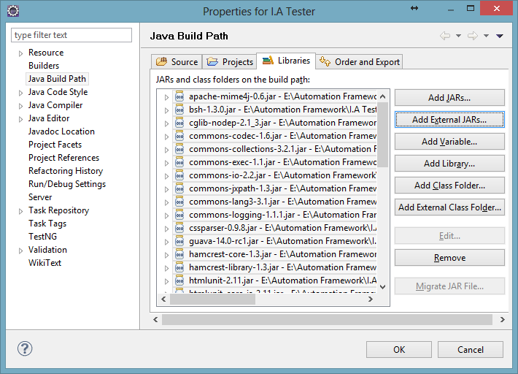

1. Press "Ok", "Ok"

**Framework Configuration**

1. Open Excecutor.java and change the setup route for the workspace route(SetUpVars)

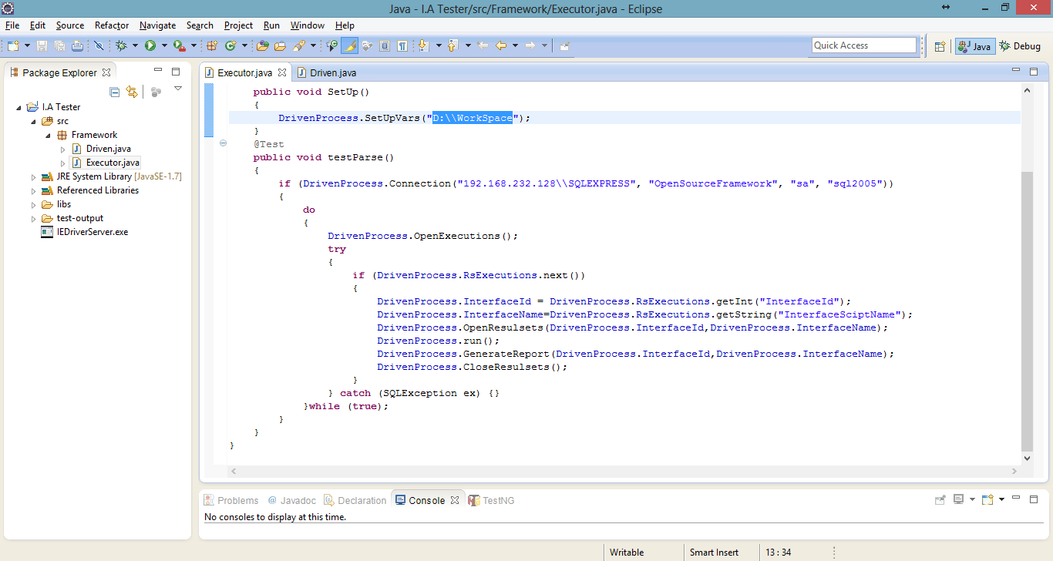

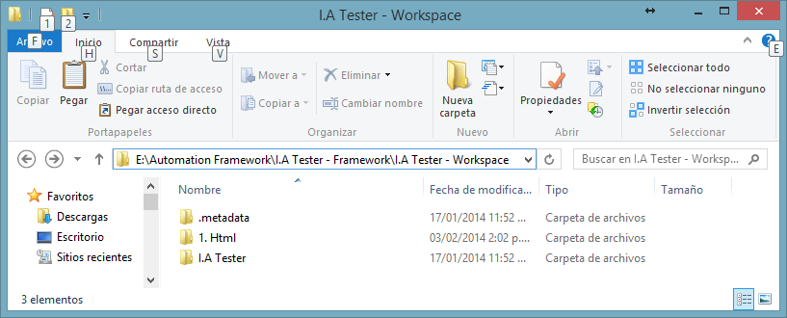

this is my route



1. Configure the SQL connection(DrivenProcess.Connection)

ServerName, DatabaseName, User, String Password

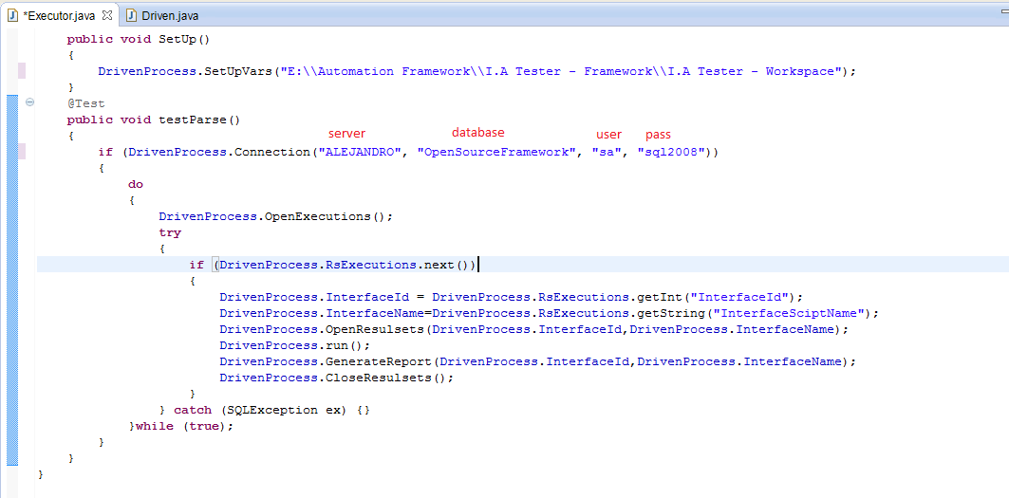

**Run our first Automation Robot.**

1. go to database and open the table "6TbExecutor"
2. edit the register with InterfaceId=1 and put ExecutionStatus=false

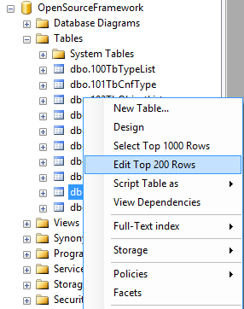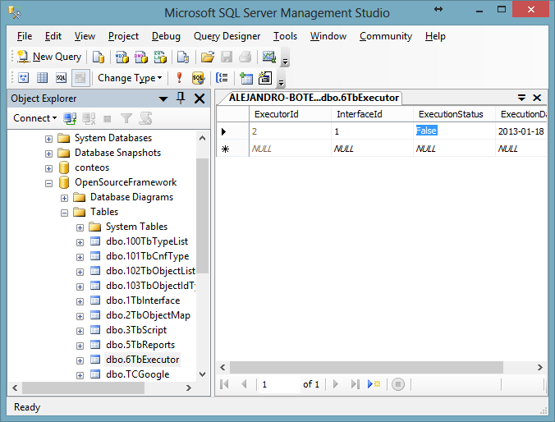

1. Go to eclipse and run "Ejecutor.Java"

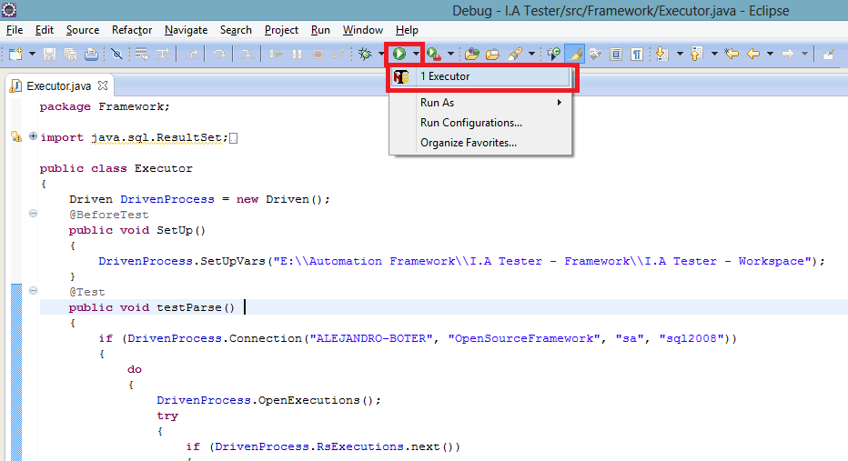

**Note: (executor is a schedule, you need run all the automation scripts with this feature.)**

**Understand and enjoy.**

**Botero5@gmail.com**

**Botero5@hotmail.com**